Mapping Our Way Through the Smog:

Researching Ulaanbaatar Air Pollution

with the Ger Community Mapping Center

Strzempko, Jessica

Academic Director: Sanjaasuren, Ulziijargal

Clark University

Environmental Science

Internship Project Supervisor: Tsevegmid, Anukhatan

Ger Community Mapping Center

Ulaanbaatar, Mongolia

Nomadism, Geopolitics, and the Environment

SIT Study Abroad, Spring 2019

Abstract

Air pollution in Ulaanbaatar, the capital of Mongolia, has reached dangerous levels in the past several decades, raising concerns for public and environmental health. Despite efforts from city government and local non-governmental organizations to develop a comprehensive plan toward a cleaner, healthier future, current actions have proven insufficient to combat the multifaceted issue. One such NGO, the Ger Community Mapping Center, has been working for 7 years in Ulaanbaatar to improve living conditions for residents of the unplanned Ger districts while also seeking to develop sustainable, inclusive communities throughout the entire city. Over the past month, I had the privilege to intern with GCMC to learn about their community mapping approach and assist them in project execution. My time with this organization focused on their 2 largest

projects currently in development – Right 2 Breathe and Switch Off Air Pollution. This paper provides an overview of my main work with GCMC placed in the context of urban development and planning as well as a summary of the experience in terms of learning objectives achieved. My internship with GCMC was highlighted by a vigorous exchange of technical teachings and cultural ideas paired with frequent observation of and research on the question of air pollution in Ulaanbaatar. In the coming years, greater education and awareness of topics surrounding air quality will serve as a fundamental initial step in the process of social and institutional change aimed at clearing the air.

**Key words:** air pollution, air quality index (AQI), Ger Community Mapping Center (GCMC), Ger district, geographic information science (GIS)

**Table of Contents**

Abstractii

Table of Contentsiii

Acknowledgementsiv

Background1

Job Description5

*Position Summary*5

*Qualifications*6

*Position Details*7

*Responsibilities & Duties*9

Focus Project10

*Right 2 Breathe*10

*Switch Off Air Pollution*16

Personal Assessment20

Conclusion25

References27

Appendix A29

Appendix B31

Acknowledgements

First and foremost, I would like to thank my parents and my sister back home in the United States. Despite the extreme time difference, the phone calls and funny text messages were a wonderful reminder of your continuous support. I’m incredibly lucky to have you all to help me through every adventure and endeavor I embark on.

The successful completion of my internship with the Ger Community Mapping Center would not have been possible without the support of my supervisor, Anukhatan Tsevegmid, as well as Batdorj Gongor and Otgonzul Enkhtuvshin. I greatly appreciate the advice and mentorship I received and look forward to staying in touch in the future.

A big thank you goes to all the employees at SIT who have made my semester abroad safe yet exciting, particularly Ulzii bagcsh, Shijir, and Maralaa. From the beautiful excursions to the hilarious language classes and everything in between, your guidance and conversation will not be forgotten.

My most heartfelt thank you to my homestay families in both Ulaanbaatar and Galuut soum. Amaa, Daarii, Düüree, Boloroo, Üüree, and Önöö – thank you for supporting me through some tough times physically and emotionally. I’ll always cherish my time in Galuut soum (and hope you received my postcard)! Ugi, Huyga, Yaruu, Ami, Anya, and Nari – the food, the laughs, and the honest discussions you’ve shared with me over the past several months have meant more to me than you’ll ever know. I can’t thank you enough for your warmth and kindness (and delicious khuushuur!).

Thanks to all my advisors at Clark University who helped me travel to Mongolia. And lastly, thank you to my friends both old and new – can’t wait to see where the future takes us!

**Background**

Founded in 2012, the Ger Community Mapping Center is a non-governmental organization seeking to create sustainable, inclusive urban communities within Ulaanbaatar and beyond through increased equality, engagement, and public service. Throughout the years, GCMC has always stood by its goals to improve city governance, bolster youth education, and ensure citizens are happy and healthy. While steady in its principles, GCMC has approached these goals from many different directions while implementing and completing relevant social projects. By bringing their broad, technical objectives down to a personal scale, the organization has gained an informed perspective from the Mongolian citizens they serve. Ultimately, this community connection is what allows GCMC to undertake their work, listening to the concerns and experiences of citizens and tackling important social issues to generate a powerful voice for change.

Compared to other capitals around the world, Ulaanbaatar is a relatively young city, emerging from the turmoil of the transition to democracy in 1990 to transform into an international metropolis and ambassador for Mongolian culture. In the 30 years since, Ulaanbaatar has grown in population from around 500,000 to just below 1.5 million residents, forming important diplomatic relationships and facilitating the movement of Mongolian goods to the international market along with the import of popular foreign products (Brinkhoff, 2019). In spite of its apparent success as a commercial and political hub for Mongolia, the city is still overwhelmed with pervasive environmental and social concerns that are exacerbated by their complexity and wide-ranging impact. While the Ulaanbaatar city administration has instituted urban maintenance and city planning measures, the capacity and development of these procedures and policies has not keep pace with the needs of the city’s growing population. The unfortunate result of these actions, or lack thereof, is a city populace suffering from poor quality of life and absence of necessary public services.

In particular, the citizens of the Ger areas, residential districts consisting of individually owned plots of land with detached homes or gers (traditional, portable felt-covered dwellings), face constant challenges as a result of their distance from the city center and lack of representation in city governance. Historically, Ger areas have always existed around Ulaanbaatar and other Mongolian municipalities, but the recent rapid growth of the city’s Ger districts due to internal migrants is stressing the already limited infrastructure and resources available (Gardiner, 2019). As of 2010, “60% of the 250,000 registered urban households” lived in the Ger areas (Guttikunda et al, 2013). Despite the size and permanence of this population, many Ger area residents lack basic amenities like clean water, consistent electricity, plumbing, and central heating. Furthermore, new arrivals to Ulaanbaatar must register with the government to receive access to healthcare and the opportunity for education and employment.

With plans to build apartment buildings that would connect to the central heating system and collaborations with international organizations to give residents more efficient cookstoves and clean water, the city government has been attempting at viable solutions (Larkin & Ganzorig, 2018). However, in 2017 as an approach to diminishing the rapid growth of Ulaanbaatar’s unplanned Ger areas, Mayor S. Batboldissued a decree discouraging new migrants from moving to the city unless they can purchase or rent existing homes or apartments, an expensive feat (Gardiner, 2019; Long, 2017). In 2018, the Ulaanbaatar city administration voted to extend this restriction on movement until 2020 (Kuo & Davaasharav, 2018). Despite the intention to slow urban sprawl and reduce the domestic sources of particulate pollution, migrants are still driven to the city by the impacts of climate change, environmental degradation, and economic downturn, regardless of a decree. Without the financial resources to move into the city center, they establish homes in the Ger areas and are unable to register with the city government to receive access to social services. Moreover, the absence of proper waste removal and the widespread use of coal-burning cookstoves in these districts creates polluted conditions with hazardous impacts for residents (Allen et al, 2013; Enkmaa et al, 2014)

To combat these problems and pick up the slack of government inefficiency, NGOs like GCMC have stepped in to facilitate public action and project implementation. Early in its existence, GCMC conducted a vulnerability assessment of urban migrants, particularly unregistered residents of Ger areas who were lacking basic social services like education, employment, and healthcare. As an example of their work outside Ulaanbaatar, the organization also surveyed herders in Arkhangai aimag on their perceptions of climate change. Moreover, they worked with the Canada Fund to promote sustainable development goals among high school students through the mapping of their neighborhoods. Throughout all these initiatives the main methodology has always been community mapping as a means to understand the context of the problems and innovate creative, suitable solutions. This unique approach sets GCMC apart from other organizations they collaborate with who may contribute a more technological or institutional perspective. Working together with other local and international NGOs on public education projects has also encouraged greater public awareness and yielded ample success. Currently, GCMC is engaged with several projects related to the pressing issue of air pollution. Their work, among other aspirations for good governance and a healthy population, aims to address modern Mongolian realities of rapid urbanization and environmental degradation.

**Job Description**

*Job Title:* Intern

*Place of Employment:*

Ger Community Mapping Center

Amar Street, Khoroo 8

Sukhbaatar District

Ulaanbaatar, Mongolia

*Supervisor:* Anukhatan Tsevegmid (Manager)

*Position Summary*

As an intern at the Ger Community Mapping Center, candidate will obtain real-world experience working with data sets collected from vulnerable social groups to bring awareness to issues of urban development and environmental degradation. Intern should expect to process and analyze existing data sets according to a set procedure and create final products that visualize the relevant data in a clean and comprehensive manner. In particular, this activity will involve importing KML Google Earth files of GPS coordinate data into ArcMap to be exported to an Excel file. Next, intern will sort through Excel sheets of GPS coordinate data and air quality data collected using the Air Visual Pro device to match time stamps. Finally, intern will join this data to GPS points in ArcMap and display the data according to the Air Quality Index chosen for the Right 2 Breathe project. It is important that the intern focus on detail and design principles during this process to ensure a quality final product.

In addition to these main responsibilities, intern is expected to research and familiarize themselves with air pollution topics related to the Right 2 Breathe project, edit English translations of educational materials created by the NGO, and train on the relevant software programs to maintain proficiency and expand their skillset. Moreover, intern will write an article or report concerning their experience with the NGO or Mongolia in general, expressing their perspective and opinion on a particular social problem. The position involves considerable time on the computer, with laptop provided by the NGO if intern does not bring their own personal computer. Intern will be expected to work independently and be professional and productive at all times.

*Qualifications*

* High school diploma or GED is required
* Candidate should have a bachelor’s degree in a related field (Environmental Science, Community Development and Planning, Geographic Information Science) or be working toward one currently
* Candidate should be eager to work on concerns of social and environmental sustainability
* Interest in geographic information science/mapping, urban development and planning, and social activism is encouraged
* High level of computer proficiency is required (particularly with Microsoft Office products: Word, Excel, Outlook, and PowerPoint)
* Intermediate experience with GIS software programs like ArcMap or is required
* Flexibility and excellent troubleshooting skills are preferred
* Candidate should have sufficient experience processing and visualizing data on programs like Excel and Tableau
* Ability to work independently and complete assignments within given time frames
* Commitment to consistent amount of work hours per week with flexibility in arrival and departure times from office
* Must be able to work with given deadlines and put in extra hours when necessary to complete project materials on time
* Excellent verbal and written communication skills and willingness to maintain open lines of communication with supervisor
* Exceptional English language grammar and vocabulary is required, beginner’s Mongolian language skills and interest in improvement is desired
* Must be able to work in a multilingual environment and maintain a patient, respectful attitude toward colleagues

*Position Details*

* Working Conditions
  + 1 room in office building northeast of Sukhbaatar Square
  + Bathroom shared with social media company and employees next door
  + Clean workspace with 1 window, fridge, microwave, and clean water dispenser
  + Wi-fi and computer equipment provided by GCMC
* Uniform Requirements
  + Casual and comfortable clothing encouraged, office is often cold
  + Formal outfits appropriate for meetings but not required
  + Cleanliness and modesty a must
* Work Hours
  + Typically 9:30 AM – 5 PM, Monday through Friday
  + Ample flexibility and room for change depending on personal or professional commitments
  + Lunch taken anywhere between 12 PM and 2 PM
  + Schedules managed on a personal basis
* Job Relationships
  + Intern will report to their supervisor, Anukhatan Tsevegmid
  + Supervisor will act as mentor and provide intern with guiding advice
  + Intern will still work closely with other employees depending on the day and the project they are currently working on (Right 2 Breathe, SOAP, etc.)

*Responsibilities & Duties*

* Maintain project data in a clear and clean fashion, ensure it can be interpreted by recipients for procedure replication at a later date
* Alert supervisor and related project managers when maps and project outputs are completed
* Ensure all visuals and materials are sent to necessary personnel in a timely manner
* Notify supervisor and/or project managers with questions and concerns
* Responsible for borrowed keys to enter office floor and GCMC room
* Promptly edit English translations of info graphics and maps, send back to coworkers when completed for dissemination
* Comply with SIT Study Abroad rules and regulations for conduct
* Comply with all GCMC policies and procedures
* Perform related intern duties as specified by supervisor, maintain adaptable attitude in changing circumstances

**Focus Project**

*Right 2 Breathe*

The focus of my time interning at the Ger Community Mapping Center was the Right 2 Breathe project, an initiative that GCMC is collaborating on with PIN (People in Need), the Women’s Association of Lawyers, and the Mongolian Environmental Civil Council with funding from the European Union and the US Embassy in Mongolia. The goal of the project is to increase awareness about personal air pollution exposure through organizational education initiatives and the establishment of mobile air quality measurements. The first objective is being accomplished through capacity building workshops and trainings for 20-50 Mongolian civil society organizations (CSOs). For instance, my supervisor, Anukhatan, and her boss, Batdorj, attended a Barriers Analysis training my third week led by People in Need examining the challenges in getting the public to protect their health against air pollution by wearing masks and educating attendees on how to best approach the problem.

The second part of the project involves measuring personal pollution exposure rates of a diverse set of Ulaanbaatar residents with the ultimate aim of using the data for advocacy purposes. The questions I spent my internship considering were how to best represent and visualize the data for use by the Right 2 Breathe project and how public perception of the impacts of air pollution factor into the actions taken by the community and government to solve the problem. Every weekday of the internship period I commuted into GCMC’s office near Sukhbaatar square to spend a typical workday reflecting on these questions as I designed and produced maps for my focus project.

In order to implement the Right 2 Breathe project, 8 pilot test individuals of various ages and backgrounds were chosen to carry GPS and Air Visual Pro devices with them on a typical commute from home to school or work and back again to record their geographical position and related air quality data in short 10 second intervals. The Air Visual Pro device used in the project measures levels of PM 2.5, PM 10, CO2, and VOCs as well as temperature, humidity, and AQI. Several participants were driven or drove to their school or workplace while most others rode the bus. 7 of the 8 participants are Ulaanbaatar residents while the last individual is a child living and attending school in Arkhangai aimag center. Routes were recorded on dates in December, January, February, March, and April to obtain a general record of air pollution throughout the months when it affects the public’s health and quality of life the most. Additionally, sensors were placed in the participants’ homes for a 24-hour period and in their school or work during the daytime to obtain a full 24-hour measurement of individual air pollution exposure. In total, 9 sets of data were collected throughout this time period with 1 individual recording her commute in both December and April. Since Batdorj had completed the first individual’s map, my role was to process and clean the data for the remaining 8 routes then map their AQI values by joining it with the GPS coordinates. The color-coded legend for the maps was determined by the Air Quality Index found in Table 1 (See Appendix A). In addition to participants’ commutes, major roads and locations of official air quality monitoring stations (run by the City Air Quality Department and the National Agency for Meteorology and Environmental Monitoring) were incorporated into the maps. These elements were included to provide context and demonstrate the need for additional monitoring stations in residential locations further from the city center.

In regard to handling the participants’ personal information, I adhered to the procedure that GCMC follows under the Right 2 Breathe project’s ethics policies. Though the pilot test individuals’ names and daily GPS coordinates for home and school or work were used, last names, ages, and specific addresses were not given. The individuals all willingly signed up to participate in the program and have certain personal information recorded and used for the study. Since my focus project was situated within the larger Right 2 Breathe project, I complied with the instructions given to me by my supervisor.

In addition to creating personal exposure maps for the Right 2 Breathe participants, I researched the issue of air pollution in Ulaanbaatar to place my work in an informed environmental and social context. Guttikunda et al (2013) is a great resource for learning further about the fuels and sources that produce particulate air pollution in the city with a comparison of how the pollution in Mongolia’s capital measures up to other major polluted cities around the world. In 2010, Ulaanbaatar emitted a total of 62,000 tons of PM 2.5 pollution placing it just below Delhi’s 63,000 tons of PM 2.5 pollution in 2010, despite Delhi being 15 times larger and having a population around 22.5 million at the time (Guttikunda et al, 2013). Furthermore, while raw coal burned in domestic cookstoves used primarily in Ger areas is the most recognized pollution source, power plants, heat-only boilers (HOBs), vehicles, resuspended dust, brick kilns, and garbage burning at makeshift landfills also contribute significant quantities of particulate pollution (Davy et al, 2011).

Although the sources have been identified and their impact on overall pollution measured, the Ulaanbaatar city administration has been struggling to implement a comprehensive, widespread solution to the intensifying issue. While resolving to “increase the number of air quality monitoring stations, provide processed fuel to target groups,” and promote technological advances in the energy sector, the government has primarily relied on reactionary actions like paid leave for parents caring for sick children or allocation of money to increase hospital capacity (Aminaa, 2018). While these actions may be necessary in the moment, a lack of foresight and proactive action will only allow the issue to worsen. Another controversy involves the city administration’s decision to extend the mayor’s 2017 suspension on migration from other provinces until 2020 (Kuo & Davaasharav, 2018). Despite the intention to curtail urban migration and thus reduce sources of particulate pollution, the policy instead increased the number of unregistered Ger area residents who are unable to access public services due their illegal status. Additionally, on May 1st, 2019, a ban on burning unprocessed raw coal in Ulaanbaatar went into effect, negatively impacting residents who purchase this fuel for its cheap price and long-burning quality (Cousins, 2019). While these steps will remove some particulate pollution, enforcement of the ban will vary especially if the city government does not provide a clean, cheap alternative. Instead, the city should be advancing long term plans to improve heating and public transportation infrastructure while investing in short term solutions like more efficient cookstoves, small-scale renewable energy projects, and awareness campaigns (Guttikunda et al, 2013).

Many non-governmental organizations throughout Ulaanbaatar are using this last approach to bring greater education about the problem of air pollution to the Mongolian public. Through the Right 2 Breathe initiative, GCMC and its collaborating partners hope to demonstrate the urgency and importance of the situation to community members by involving them in the process of the research. The collection of personal exposure data and its visualization through the maps Batdorj and I have created will help Ulaanbaatar residents recognize that they need to take preventative measures to protect their health like wearing masks, using air purifiers, and avoiding outdoor activity at times of peak pollution. Once the project committee of organizations decides on an appropriate layout, they will create posters with the personal exposure maps, a legend, an inset map for context, and graphs of the level of PM 2.5 pollution in the participants’ homes, schools, and workplaces for the given time period. While the ultimate goal of awareness is intangible, the personal pollution exposure maps provide a necessary record of quantitative data as well as a powerful message about this major social and environmental issue. In the future, GCMC plans to expand this project by recording the personal air pollution exposure for even more individuals in Ulaanbaatar to produce a larger database of evidence of the harmful environmental conditions as a means to stimulate social and policy change. In this framework, the creation of the pilot test maps is crucial to the further success and continuance of the Right 2 Breathe project.

See Appendix B for the personal exposure maps and graphs and Appendix A for related tables and legends. For the pilot test individual #2, graphs and an overview map were added for context – these were created for all participants by Batdorj Gongor and I but were considered unnecessary to include in the report due to their redundant information and large quantity. The graphs of PM 2.5 levels in the participant’s home and school were important in understanding and displaying patterns of diurnal pollution. Furthermore, a record of high pollution in public schools heated by individual boilers indicates a need for cleaner fuel in spaces meant to be safe and productive for young children.

In looking at the array of maps created for the project, it becomes apparent that each one tells the story of a unique person’s lifestyle and livelihood. For instance, pilot test individual #4 is a taxi driver who was transporting customers around the city from around 10:00 AM to 10:00 PM on the day his personal exposure data was collected (Figure 9). His data demonstrates that he experienced extreme highs (AQI=1358) and extreme lows (AQI=4) during his 12-hour shift, which is consistent with the fact that he drives through many different districts of the city at varied times of the day. Another example lies in pilot test individual #6 who lives in Arkhangai aimag center. In her personal exposure map, the pollution spikes from an AQI of 42 all the way up to an AQI of 440 in only 20 minutes (Figure 12). In aimag centers, it is common to see many small coal-fired power plants with thick, black smoke trailing from their smokestacks as these municipalities often don’t have 1 central heating system but many. Pilot test individual #6 most likely walks past a power plant or in the direction the smoke is being blown leading her to experience localized high pollution. In this manner, the maps created for the Right 2 Breathe project collectively constitute a comprehensive understanding of air pollution in Ulaanbaatar and beyond, woven in between the narrative of Mongolian life.

*Switch Off Air Pollution*

In addition to the personal exposure maps, I helped edit English translations of educational info graphics created for the SOAP (Switch Off Air Pollution) project that GCMC is currently helping to implement. The SOAP project is funded by the Switch Asia II program through the European Union and is being implemented by GERES (Group for Environment, Renewable Energy and Solidarity) with help from PIN (People in Need), GCMC, MUST (Mongolia University of Science and Technology) through BEEC (Building Energy Efficiency Centre), and MNCA (Mongolia National Construction Association). The intention of SOAP, which is one of many Switch Asia II projects promoting sustainable consumption and production, is to assist residents in the unplanned Ger areas of Ulaanbaatar in overcoming obstacles like money, information, and labor when trying to insulate their homes.

In its beginning stages, the project sought to build a foundation of knowledge about existing attitudes and behaviors, available energy efficient construction materials on the market, capacity of construction enterprises, and current insulation conditions in target khoroos. With this information, an online application is being built to help households through the process of retrofitting their homes with insulation. Initially, participating households will connect with a technical assessor to obtain an energy efficiency assessment of their homes which will include the most appropriate insulation method and the approximate cost. Should the household decide to move forward with the process and need assistance paying for the installation, they will then apply for a loan through Khas Bank which has offered special low interest rates for eligible households. Next, SOAP will help intermediate for the required insulation materials meeting designated quality standards which will be installed by construction brigades chosen specifically for the project. Finally, an energy auditor will visit the home to check the quality of the installation and calculate the increase in energy efficiency as a result of the new insulation. The SOAP project is unique from other energy efficiency initiatives in Ulaanbaatar because the households that participate are responsible for paying for the entire cost of the retrofitting and receive no subsidies as assistance. The project has found that this approach encourages participants to advocate for themselves, asking questions and ensuring that they are receiving quality work for their investment.

The info graphics that GCMC created for this initiative are the culmination of surveys conducted with 416 randomly selected households living in conventional homes in the Sukhbaatar and Songino Khairkhan districts from a total of 11 target khoroos. This baseline study report for the SOAP project asked questions regarding current insulation and heating conditions in homes as well as attitudes around air pollution and energy efficiency. In assisting my supervisor, Anu, and her coworker, Oogy, with the English translations of these info graphics, I learned that there is a general lack of knowledge around the air quality index, though residents are taking steps to protect their health from pollution by wearing masks, boosting their immune systems, using air purifiers, and avoiding the outdoors during peak pollution times. Additionally, residents are unsure if their homes are losing heat and require insulation, but also face the obstacles of time, labor, and money to assess the problem and hire a professional insulator to install the insulation properly. MNCA also helped the project in obtaining information about the demographics of construction enterprises including their average income, gender composition, active work season, job specialization, and experience working on homes in Ger areas. Most Ulaanbaatar construction enterprises work March to December and the majority of brigades earn 30 million MNT or less annually. Unfortunately, 89% of the participants in the survey said that in the last 3 years there had been at least 3 cases where they were not paid for their work. Ultimately, this survey and data collection contributed to the project by narrowing down the brigades and workers to those with adequate experience and suitable job specialization willing to work on Ger areas homes. Participation in the project by these brigades offers consistent work opportunities as well as a dependable paycheck from the insulating households. The data collected in the info graphics is likewise a thorough summary of the stakeholder demographics and provides project implementers with the aspects of the process that need the most improvement.

Similar to the maps, the info graphics are succinct, visually appealing illustrations of the quantitative information collected for the project. Many of the findings portrayed in the info graphics convey the message that Ulaanbaatar residents may have a general lack of knowledge surrounding insulation and heating but are eager to learn further and improve their living situation whether it be for personal or community benefit. The fact that project participants are willing to potentially invest in home improvements to increase energy efficiency and reduce air pollution bodes well for the reception of other social initiatives among Ulaanbaatar residents. By developing a market for technical assessors and professional insulators, the SOAP project is ensuring the longevity of this positive development. Finally, it is one component in addressing the critical issue of air pollution plaguing Ulaanbaatar brought on by rapid and unplanned urbanization.

**Personal Assessment**

My internship with the Ger Community Mapping Center fostered many positive professional and personal developments within me. For one, the completion of my focus project and my time spent collaborating on mapmaking with Batdorj were excellent opportunities to expand my skillset and range of experience. Previously, in my university’s geographic information science classes, I had only completed mapping projects within the scope of the textbook’s tutorials, excluding my final projects. While the final projects taught me how to procure and manipulate real-world data from formal sources, the purpose was purely educational, and the result was not of major consequence. Knowing that the maps I created for the Right 2 Breathe project would be used for a wider awareness campaign to generate social change in Ulaanbaatar gave the work a more direct constructive purpose. Moreover, I appreciated the chance to work with Batdorj, who does not have formal training on ArcMap software, as he taught me tips and shortcuts he had learned over the years. We also resolved many small problems together by using our collective experiential and classroom knowledge as well as the ever-helpful internet with its online forums.

This was in contrast to when I visited TNC (The Nature Conservatory) to speak with their GIS specialist about his career and work at the NGO. Not only is TNC larger than GCMC in terms of manpower and funding capacity, but their GIS specialist spoke to me about how he received a bachelor’s degree in GIS and remote sensing before coming to work with TNC. Considering the distinct goals of each of these NGOs, social sustainability through community partnership versus global environmental conservation by mode of scientific research, the differences in approach are understandable. The comparison of the mapping techniques used in both of these NGOs reminded me that the design and information included in the final product is critical in serving the ultimate purpose of the map. The experience helped clarify what community mapping is and what sets it apart from other modes of mapping I had encountered. Additionally, the focus on social activism and change that community mapping requires is fundamental to the GCMC’s mission to create sustainable, safe, and inclusive communities.

Along these lines, working on the Right 2 Breathe project and familiarizing myself with the Ger area lifestyle the participants were living was a great lesson in empathy. When hearing about the problem of air pollution from different sources during my first months in Mongolia, some individuals I met perpetuated a narrative that essentially blamed the Ger area residents for their use of dirty coal as a fuel. While it is true that domestic cookstoves produce a considerable portion of the pollution in Ulaanbaatar, the statement of this fact alone ignores the socioeconomic factors that have placed Ger areas residents in their current circumstances. Not only are residents financially unable to purchase apartments, but the abundance of coal in Mongolia combined with political incapacity to create meaningful institutional change leads to a convenient lifestyle with harmful, long-term outcomes. In speaking to Batdorj about GCMC and the organization’s past work educating high schoolers on sustainable development goals, his sincerity and passion reminded me that the work must always be grounded in a human element for it to succeed.

Beyond these insights specific to mapping, my internship added significantly to my professional network. After I receive my bachelor’s in environmental science next year, I plan to continue to study at my university for an additional year through a 5th year master’s program in geographic information science. I consider myself incredibly fortunate to have worked with GCMC this past month on a topic related to my career interests. Furthermore, I now have contacts in Mongolia that I can connect with in the future should I decide to return to the country in a professional context.

In terms of concrete developments, the routine technical problem-solving involved in mapmaking increased my adaptability and enhanced my use of the trial-and-error approach. Coming into my internship, I was easily overwhelmed by large amounts of new information and uncertain about my ability to brainstorm proper solutions. After working on a project with countless minor procedural obstacles, I learned much about stepping away from a problem, putting my energy toward another productive task, and returning to the initial issue with a clear head at a later time. I also improved my competence in using the google search engine and coworkers to crowdsource potential solutions for testing. With a greater ability to adapt came less anxiety about inconsequential matters like office work hours, which I could change to accommodate my schedule. Certainly working in a place long enough will make a person more comfortable with the daily operations, yet I think GCMC specifically taught me how important it is to be flexible and willing to allow the workflow process to progress naturally at the outset.

I also learned to extend this attitude and approach to office matters. A frustration of mine throughout much of the internship was that my supervisor would not arrive at consistent times or alert me if she would be gone all day at a meeting, leading to several times when I was locked outside of the office and had to sit and wait for someone to arrive. By the last week, I was able to borrow a key from one of my coworkers so that I could arrive when I wanted to. Additionally, unfamiliar individuals would enter the office, and no one would provide me with an introduction. After speaking to my academic director and program assistant about the situation, I learned that it is common in Mongolian office culture for there to be a lack of formal introductions with employees and individuals coming and going on their terms with little communication. I could see how this behavior was also expected when working on a project as my coworkers seemed receive a task and start with no questions or further consultation. As a person who works best with clear instructions, the circumstances encouraged me to speak up for myself when I wanted more information or needed further data to continue my work. I learned that if I needed a greater level of communication between myself and my supervisor or other coworkers, I simply had to ask for it, even if it could feel overwhelming to speak up in a small 1 room office where everyone is quiet and focused.

Finally, the language barrier was most difficult for me and something I learned to practice patience with. Definitely, some of the complications I had with communication stemmed from the fact that Mongolian was the first language for all of the people I worked with. All of the meetings and small talk conducted in the office were in Mongolian which often left me guessing at what had been said. My supervisor’s English is excellent, but I felt bad relying on her to translate every small interaction for my clarification. I believe my inadequate Mongolian skills made it more complicated for me to develop personal relationships with my coworkers and disadvantaged me when I wanted to learn more about the organization’s structure and history. On the other hand, working in a multilingual office was a fascinating experience with many learning opportunities. Having lunch with my supervisor gave me the chance to practice my Mongolian, check my pronunciation, ask her about confusing phrases I had heard, and learn everyday slang words. My proficiency in English was also incredibly helpful to them as they could ask me to edit English translations of important documents, read through emails for grammatical errors, and check that they were using appropriate vocabulary. Some of the most amusing situations happened when I would attempt to say new Mongolian phrases or have to repeatedly pronounce a funny English word for my coworkers. The cultural and lingual exchange was hilarious and extremely interesting; I loved explaining parts of my life that seemed strange to them and vice versa. The experience left me more open to working in a multilingual, multinational office in the future and improved my language skills, in terms of learning and teaching.

**Conclusion**

Air pollution is a major public health concern in Ulaanbaatar and needs to be addressed with comprehensive, multi-faceted solutions. The projects GCMC is helping to implement are several of the many approaches being taken by local and international NGOs to combat the problem. Unfortunately, the circumstances have been allowed to deteriorate to a point where the pollution is hazardous to the health of many Ulaanbaatar residents (Enkmaa et al, 2014). The mapping work I completed while interning with GCMC is part of a larger, educational initiative to demonstrate to important stakeholders the severity of the situation while ensuring there is quantitative documentation of the environmental conditions. The high levels of particulate pollution experienced by the participants in the Right 2 Breathe project are evidence of the drastic need for political and institutional action. The Switch Off Air Pollution project is another initiative GCMC is working on that aims to assist homeowners who want to insulate their homes but lack the time, information, labor, and money.

Inherent in all the projects GCMC works on is the acknowledgement that citizens need to be given the proper tools to solve their own problems for community conditions to improve. It can seem efficient to conduct entire projects with minimal local assistance and consultation, but the lack of sustainability in this approach will ultimately degrade community relations and produce only short-term reparations. The research I conducted with the Ger Community Mapping Center will have broad positive impacts on public health by prompting the community and city administration to enact policy change. Moving forward, GCMC’s continuance of the Right 2 Breathe project will be crucial in targeting heavily polluted khoroos for development initiatives and documenting the potential future decrease in air pollution. Finally, it remains important to remember that NGOs cannot perform this work and solve such a widespread issue alone; they must collaborate with community, industry, and government on a range of resolutions. In order to realize the desired outcomes, the citizens and city government of Ulaanbaatar must be willing to invest resources in infrastructure, innovation, and awareness campaigns. Only then will the pollution clear to reveal a happy, healthy population living and breathing free under the beautiful Mongolian sky.

**References**

Allen, R. W., Gombojav, E., Barkhasragchaa, B., Byambaa, T., Lkhasuren, O., Amram, O., ... & Janes, C. R. (2013). An assessment of air pollution and its attributable mortality in Ulaanbaatar, Mongolia. *Air Quality, Atmosphere & Health*, *6*(1), 137-150.

Aminaa, K. (2018, January 5). Government pledges to intensify fight against air pollution. *Monstame*, The Mongol Messenger. Retrieved from: <https://montsame.mn/en/read/132984>

Brinkhoof, T. (2019). *City Population*, Historical Population Figures. Retrieved from: <https://www.citypopulation.de/php/mongolia-admin.php?adm1id=511>

Cousins, Sophie. (2019). Air Pollution in Mongolia. *Bulletin of the World Health Organization, 97*, 79-80. doi: <https://dx.doi.org/10.2471/BLT.19.02.02019>.

Davy, P. K., Gunchin, G., Markwitz, A., Trompetter, W. J., Barry, B. J., Shagjjamba, D., & Lodoysamba, S. (2011). Air particulate matter pollution in Ulaanbaatar, Mongolia: determination of composition, source contributions and source locations. *Atmospheric Pollution Research*, *2*(2), 126-137.

Enkhmaa, D., Warburton, N., Javzandulam, B., Uyanga, J., Khishigsuren, Y., Lodoysamba, S., Enkhtur, S. & Warburton, D. (2014). Seasonal ambient air pollution correlates strongly with spontaneous abortion in Mongolia. *BMC pregnancy and childbirth*, *14*(1), 146.

Gardiner, B. (2019, March 26). Kids suffer most in one of Earth's most polluted cities. *National Geographic*, Environment: The Cities Issue. Retrieved from: <https://www.nationalgeographic.com/environment/2019/03/mongolia-air-pollution/?fbclid=IwAR2-N17wt22Ti1TEBLhqC9uOui_DJyJji9MsXPcTKn2q7cTIM36fQdX25VQ>

Guttikunda, S. K., Lodoysamba, S., Bulgansaikhan, B., & Dashdondog, B. (2013). Particulate pollution in Ulaanbaatar, Mongolia. *Air Quality, Atmosphere & Health*, *6*(3), 589-601.

Kuo, L. & Davaasharav, M. (2018, September 24). Pollution pushes Mongolia’s herders to reconsider city life. *The Guardian*, Environment: Pollution. Retrieved from: <https://www.theguardian.com/world/2018/sep/24/pollution-pushes-mongolias-herders-to-reconsider-city-life>

Larkin, J. & Ganzorig, G. (2018, August 16). Can Urban Planning Help Ulaanbaatar Glimpse a Brighter Future? *Asian Development Bank*, Project Results and Case Studies. Retrieved from: <https://www.adb.org/results/can-better-urban-planning-help-ulaanbaatar-glimpse-brighter-future>

Long, P. (2017, May 31). Mongolia’s Capital Copes with Rapid Urbanization. *The Asia Foundation Blog*. Retrieved from: <https://asiafoundation.org/2017/05/31/mongolias-capital-copes-rapid-urbanization/>

Appendix A: Guiding Information for Graphs and Maps

*Table 1.* Air Quality Index used for the following personal exposure maps.

|  |  |  |  |
| --- | --- | --- | --- |
| AQI Designation | AQI Values | PM 2.5 (μg/m³) | Health Impacts |
| Clean | 0-50 | 0-15 | Air quality is satisfactory, air should pose little to no risk to health |
| Normal | 51-100 | 15-40 | Air quality is acceptable, moderate health concern for vulnerable population |
| Low Pollution | 101-200 | 40-150 | Air quality has become unhealthy for vulnerable groups |
| Moderate Pollution | 201-300 | 150-250 | Air quality is unhealthy for the entire population, limit prolonged time outdoors |
| High Pollution | 301-400 | 250-350 | Air quality is very unhealthy, emergency conditions apply |
| Very High Pollution | 401-500+ | 350-500+ | Air quality is hazardous, and everyone should avoid all outdoor exertion |

*Table 2.* Brief data summary of 8 participants mapped during completion of focus project.

|  |  |  |  |  |
| --- | --- | --- | --- | --- |
| Participant Number | Participant Name | Date of Data Collection  (day/month/year) | Maximum AQI | Minimum AQI |
| 1 | OyunErdene* | 19/12/2018 | 542 | 110 |
| 2 | Enkhkhishig | 20/12/2018 | 699 | 66 |
| 3 | Khosbayar | 24/12/2018 | 990 | 59 |
| 4 | Ganbold | 27/12/2018 | 1358 | 4 |
| 5 | BurteUjin | 11/01/2019 | 884 | 78 |
| 6 | Angarag | 21/02/2019 | 440 | 38 |
| 7 | Ariunzaya | 27/02/2019 | 405 | 82 |
| 8 | Turbold | 12/03/2019 | 190 | 29 |
| 1 | OyunErdene | 04/04/2019 | 172 | 8 |

***\*****The personal exposure map for OyunErdene’s December 19th, 2018 commute was completed before the undertaking of this focus project and was thus not included with the maps in Appendix B.*

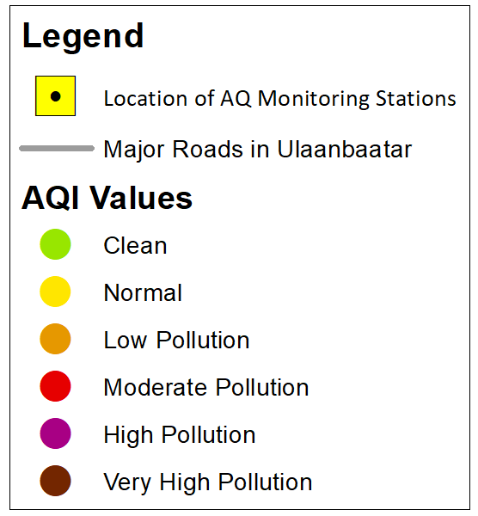

*Figure 1.* Legend for the following personal air pollution exposure maps.

**Appendix B: Personal Exposure Graphs and Maps**

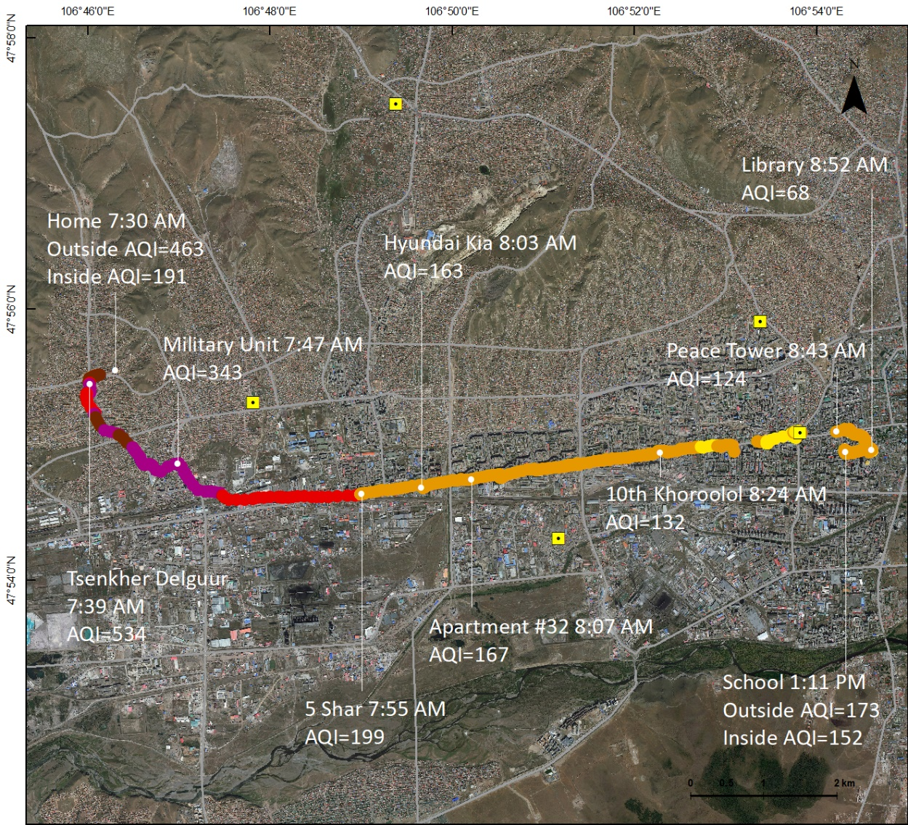

*Figure 2.* [pilot test individual #2] Enkhkhishig’s commute from her home to the library 7:30-8:52 AM and the library to her school 1:02-1:11 PM on December 20th, 2018. Her maximum AQI value was 699 (PM 2.5 = 801.8 μg/m³) and minimum value was 68 (PM 2.5 = 20 μg/m³).

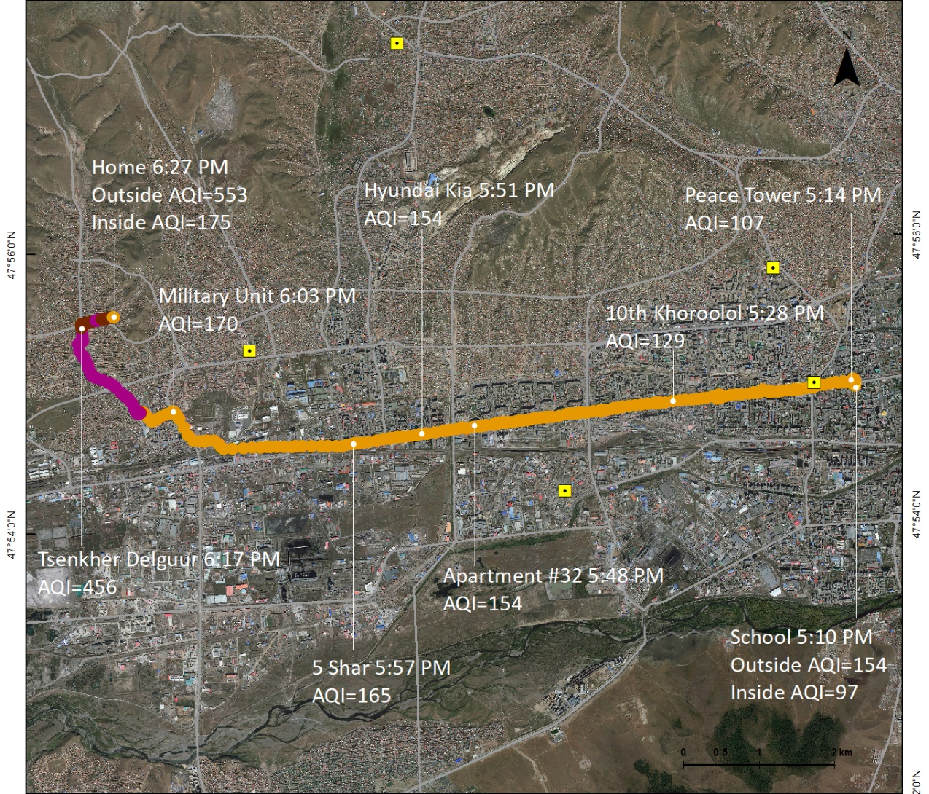

*Figure 3.* [pilot test individual #2] Enkhkhishig’s commute from school to home 5:10-6:27 PM on December 20th, 2018. Her maximum AQI value was 585 (PM 2.5 = 628.8 μg/m³) and minimum value was 66 (PM 2.5 = 19 μg/m³).

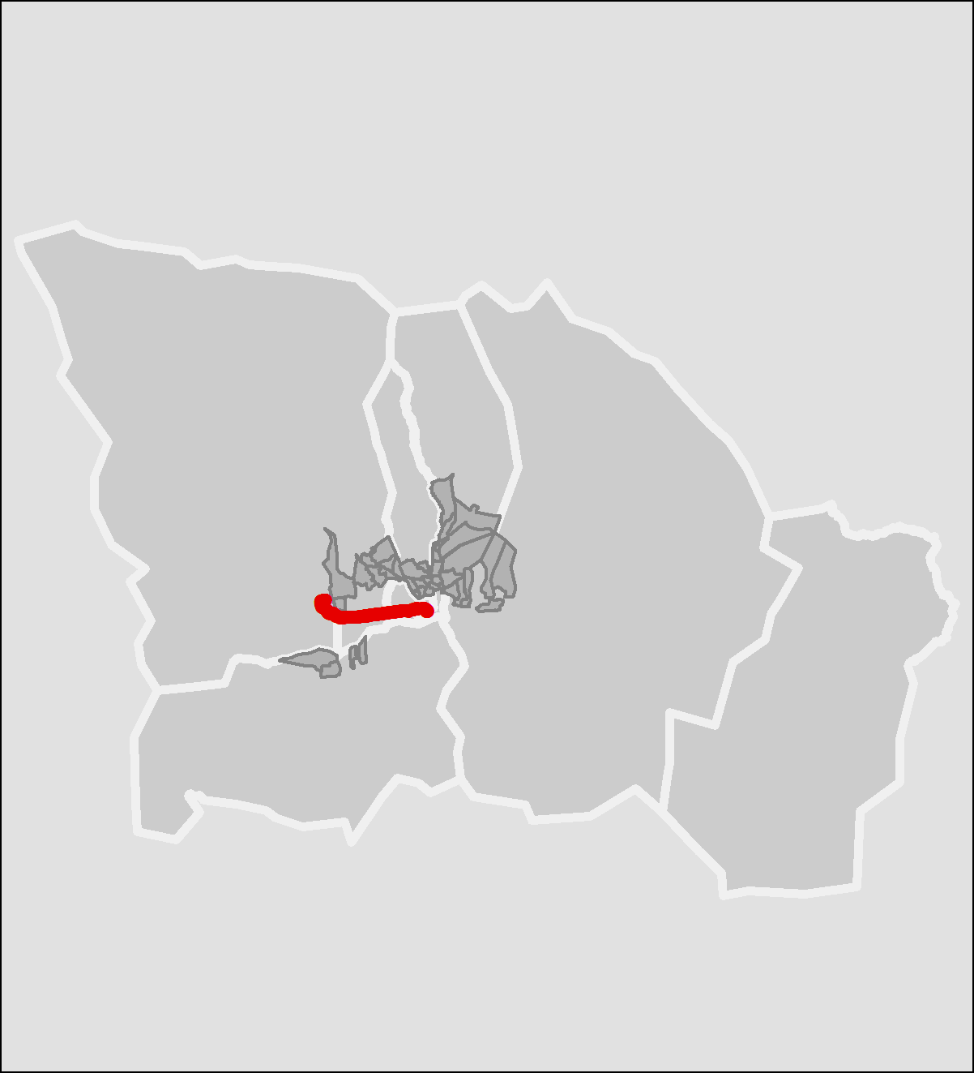

*Figure 4.* [pilot test individual #2] An overview map of Enkhkhishig’s commute between school to home on December 20th, 2018. The red line indicates the route she traveled, the large grey polygons are the 7 central districts (*düüregs*) of the municipality of Ulaanbaatar, and the small dark grey polygons are the target sub-districts (*khoroos*) focused on by the Right 2 Breathe pilot project.

*Figure 5. Courtesy of Batdorj Gongor/GCMC* [pilot test individual #2] Graph of PM 2.5 levels in Enkhkhishig’s home from 7:07 AM on December 20th, 2018 to 7:07 AM on December 21st, 2018.

*Figure 6. Courtesy of Batdorj Gongor/GCMC* [pilot test individual #2] Graph of PM 2.5 levels in Enkhkhishig’s school classroom from 1:15-5:00 PM December 20th, 2018.

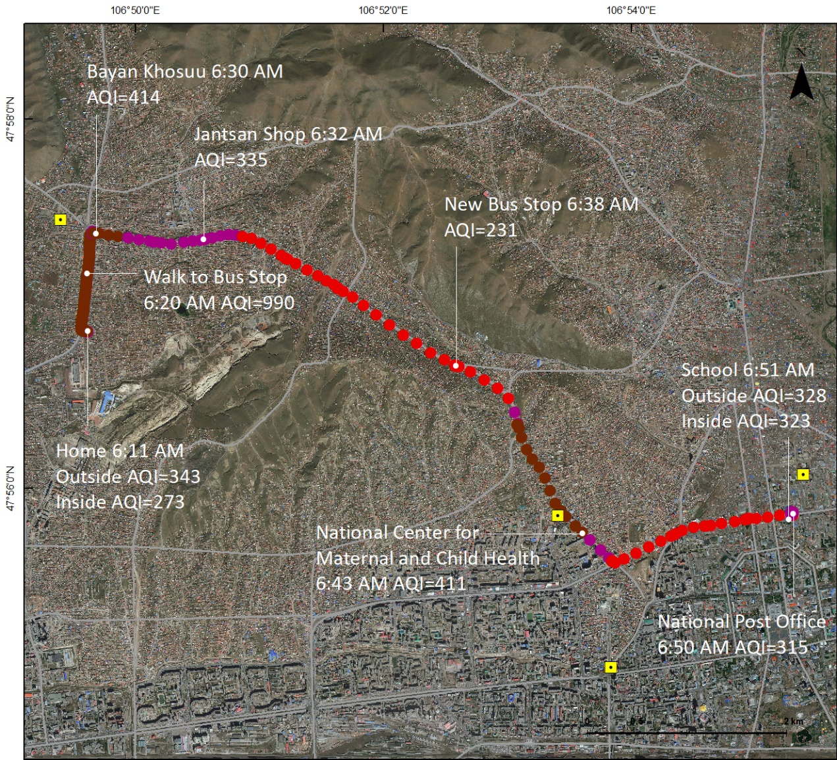

*Figure 7.* [pilot test individual #3] Khosbayar’s commute from home to school 6:11 – 6:51 AM on December 24th, 2018. His maximum AQI value was 990 (PM 2.5 = 1242 μg/m³) and minimum value was 197 (PM 2.5 = 144.7 μg/m³).

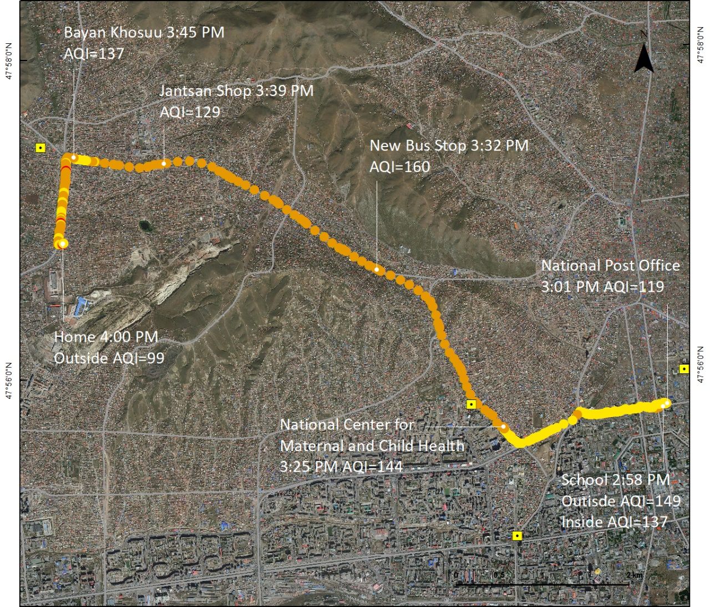

*Figure 8.* [pilot test individual #3] Khosbayar’s commute from school to home 2:58-4:00 PM on December 24th, 2018. His maximum AQI value was 270 (PM 2.5 = 220 μg/m³) and minimum value was 59 (PM 2.5 = 16 μg/m³).

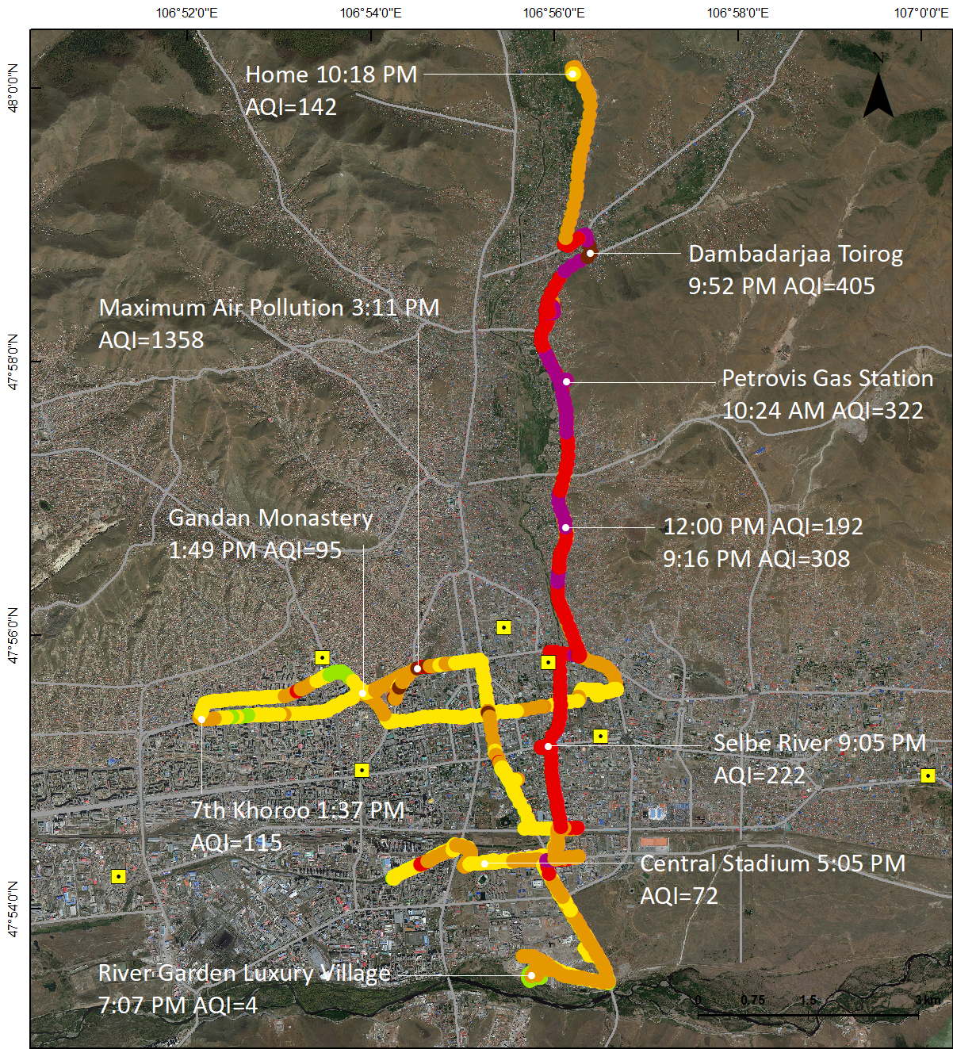

*Figure 9.* [pilot test individual #4] Ganbold’s workday as a taxi driver spent driving from 10:24 AM-10:50 PM on December 27th, 2018. His maximum AQI value was 1358 (PM 2.5 = 1798.8 μg/m³) and minimum value was 4 (PM 2.5 = 1 μg/m³).

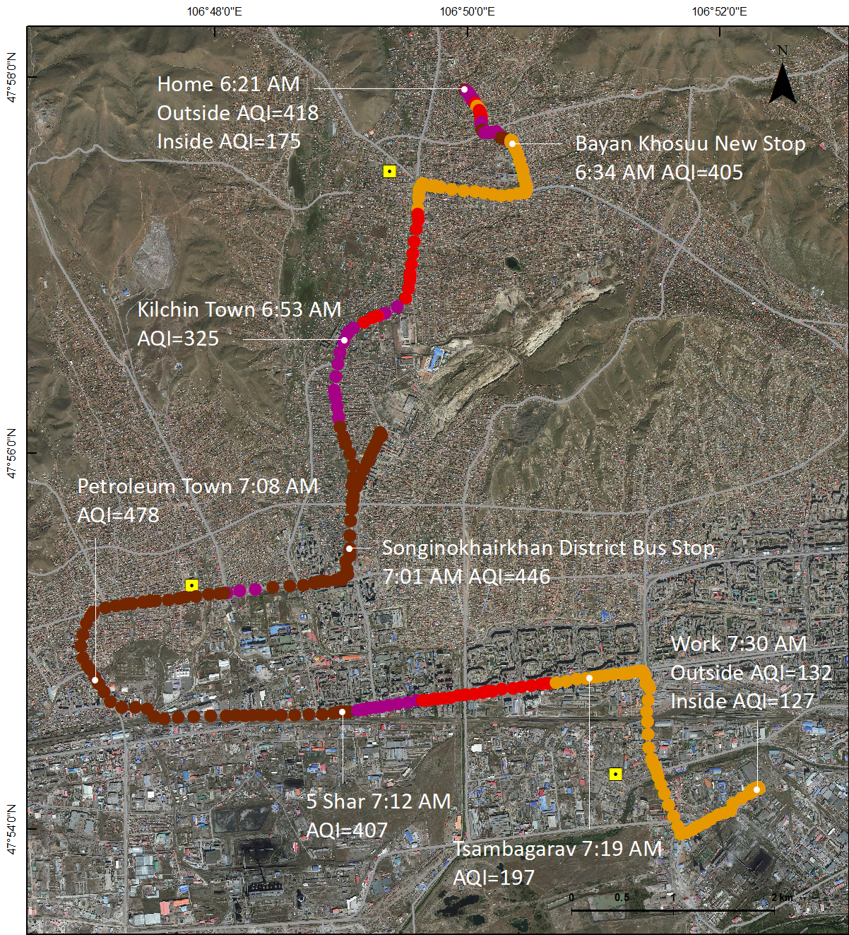

*Figure 10.* [pilot test individual #5] BurteUjin’s commute from home to work 6:21-7:30 AM on January 11th, 2019. Her maximum AQI value was 500 (PM 2.5 = 500.6 μg/m³) and minimum value was 124 (PM 2.5 = 45 μg/m³).

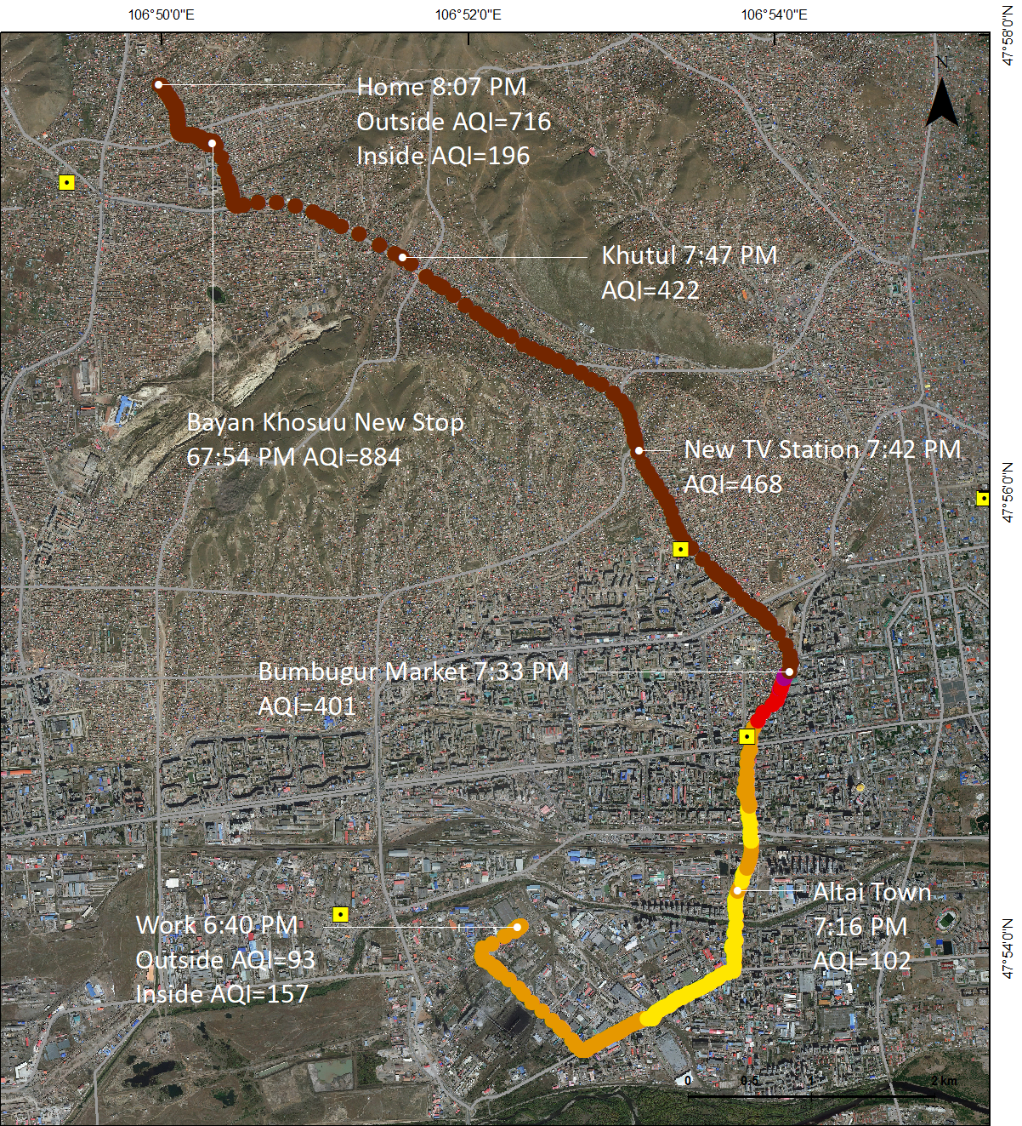

*Figure 11.* [pilot test individual #5] BurteUjin’s commute from work to home 6:40-8:07 PM on January 11th, 2019. Her maximum AQI value was 884 (PM 2.5 = 1082.4 μg/m³) and minimum value was 78 (PM 2.5 = 25 μg/m³).

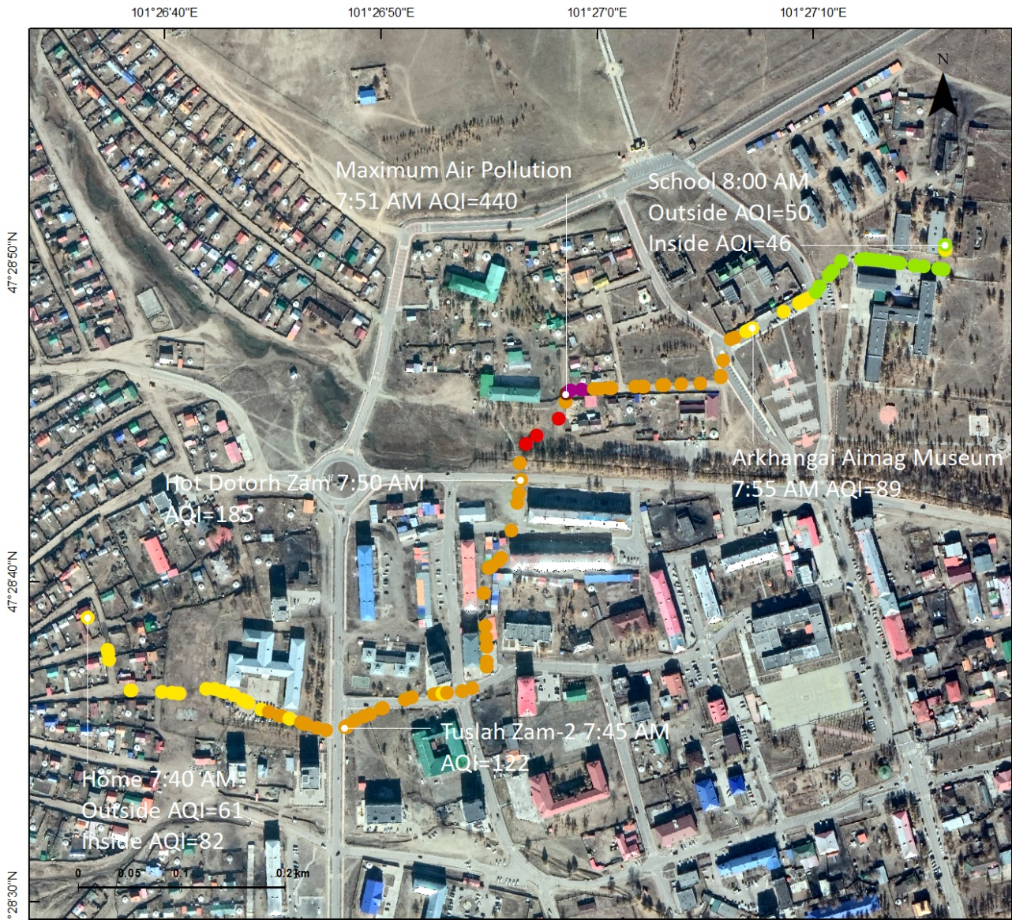

*Figure 12.* [pilot test individual #6] Angarag’s commute from home to school 7:40-8:00 AM on February 21st, 2019 in Arkhangai aimag center. Her maximum AQI value was 440 (PM 2.5 = 410 μg/m³) and minimum value was 42 (PM 2.5 = 10 μg/m³).

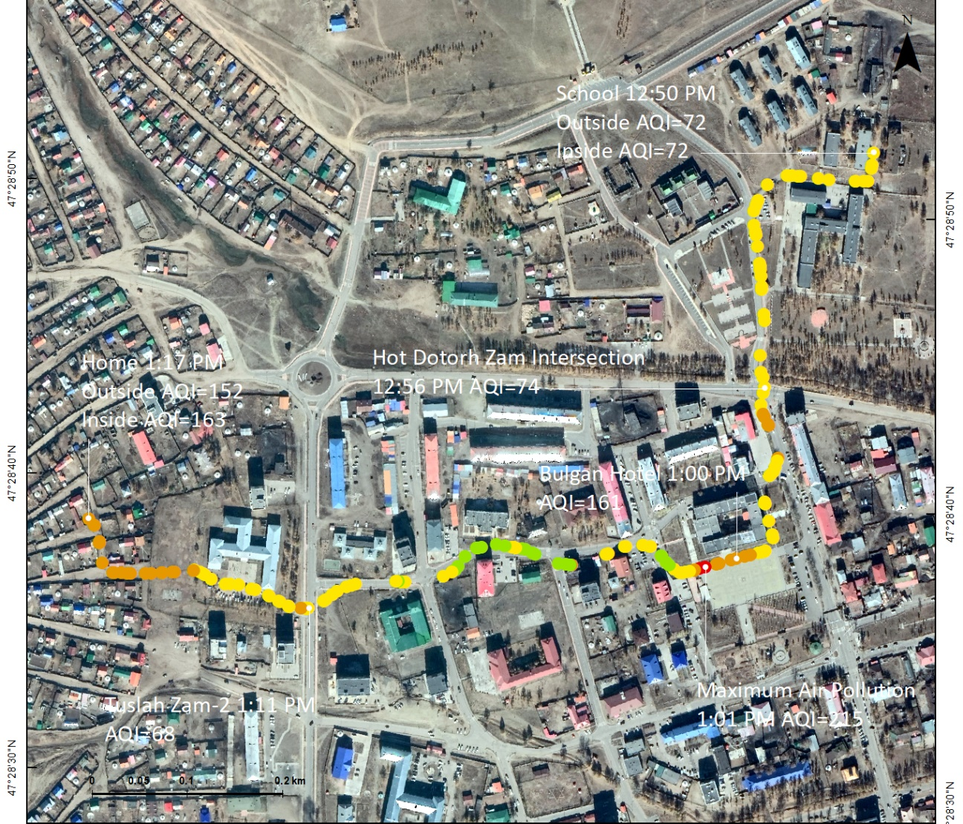

*Figure 13.* [pilot test individual #6] Angarag’s commute school to home 12:50-1:17 PM on February 21st, 2019 in Arkhangai aimag center. Her maximum AQI value was 215 (PM 2.5 = 164 μg/m³) and minimum value was 38 (PM 2.5 = 9 μg/m³).

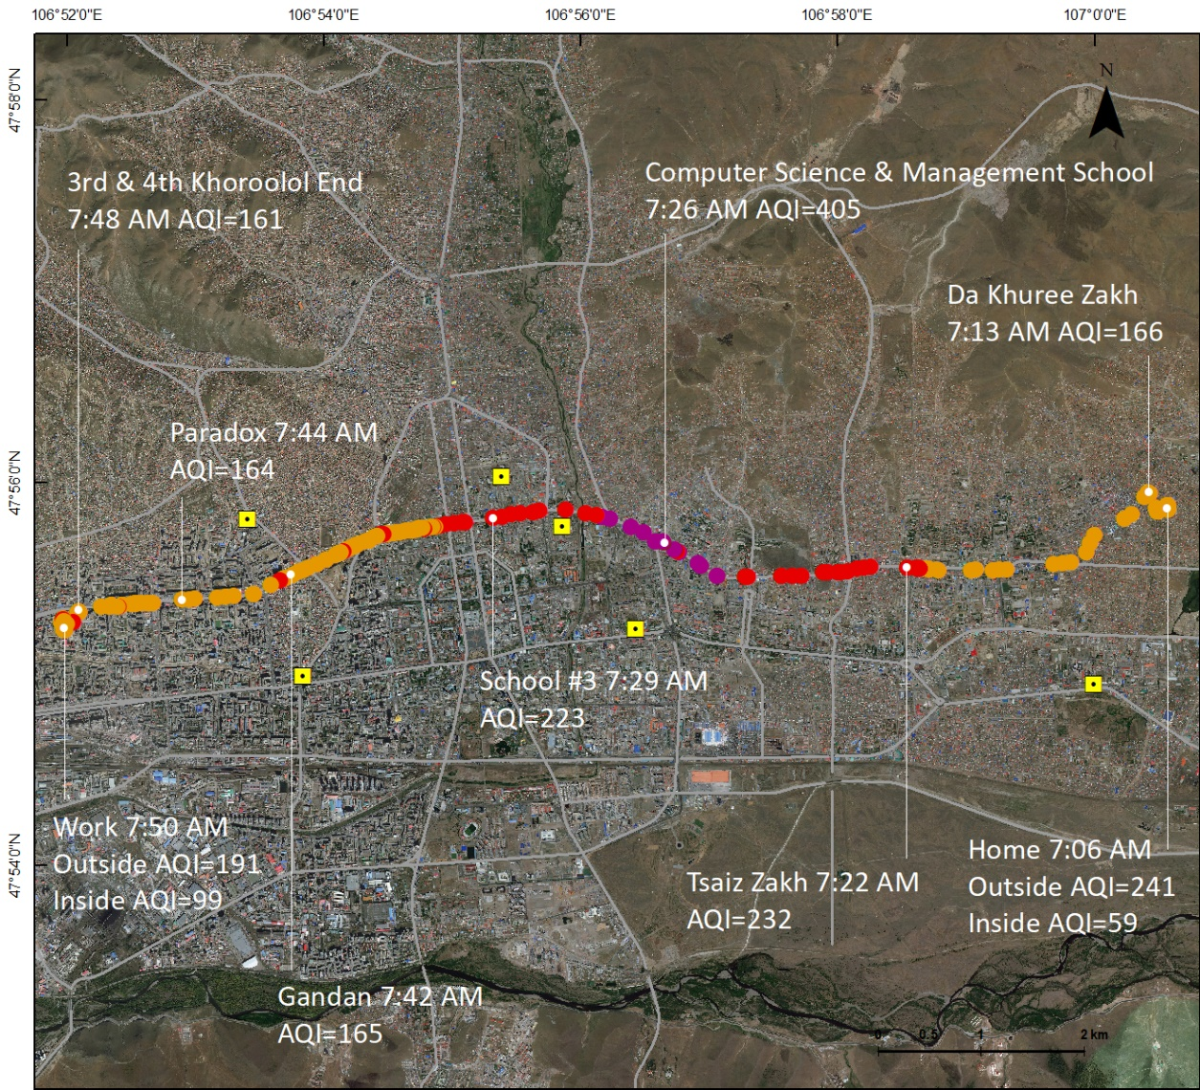

*Figure 14.* [pilot test individual #7] Ariunzaya’s commute from home to work 7:06-7:50 AM on February 27th, 2019. Her maximum AQI value was 405 (PM 2.5 = 357.1 μg/m³) and minimum value was 107 (PM 2.5 = 38 μg/m³).

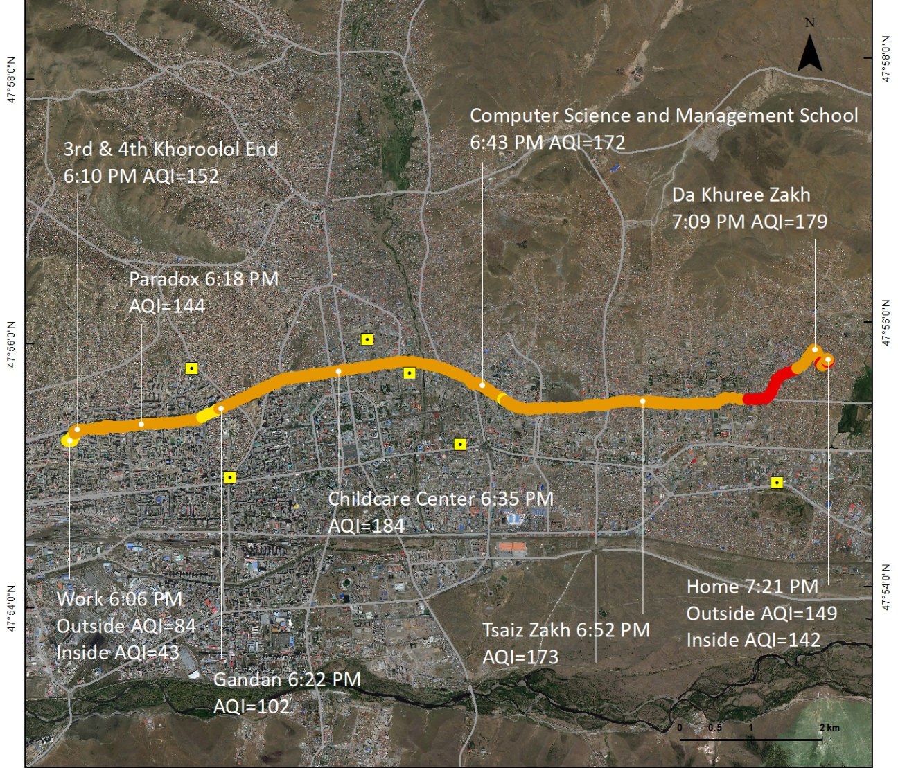

*Figure 15.* [pilot test individual #7] Ariunzaya’s commute from work to home 6:06-7:21 PM on February 27th, 2019. Her maximum AQI value was 303 (PM 2.5 = 252.2 μg/m³) and minimum value was 82 (PM 2.5 = 27 μg/m³).

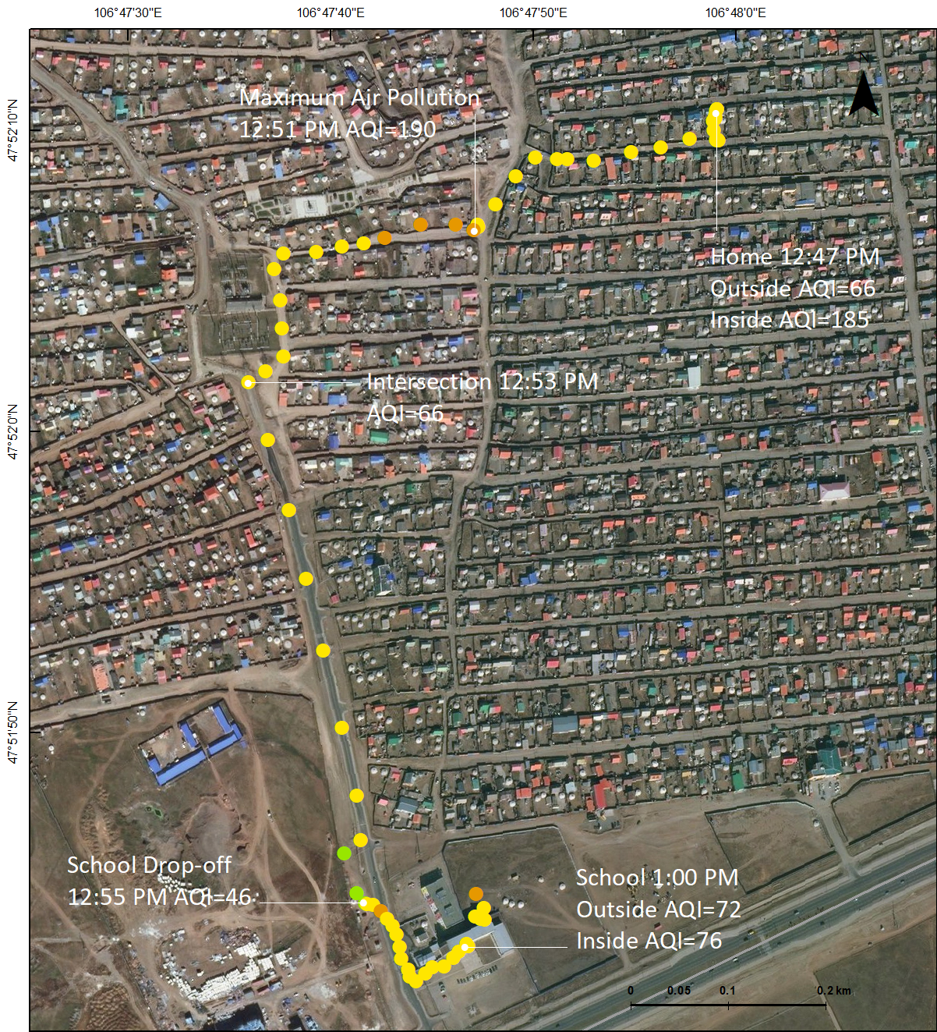

*Figure 16.* [pilot test individual #8] Turbold’s commute from home to school 12:47-1:00 PM on March 12th, 2019. His maximum AQI value was 190 (PM 2.5 = 131.2 μg/m³) and minimum value was 42 (PM 2.5 = 10 μg/m³).

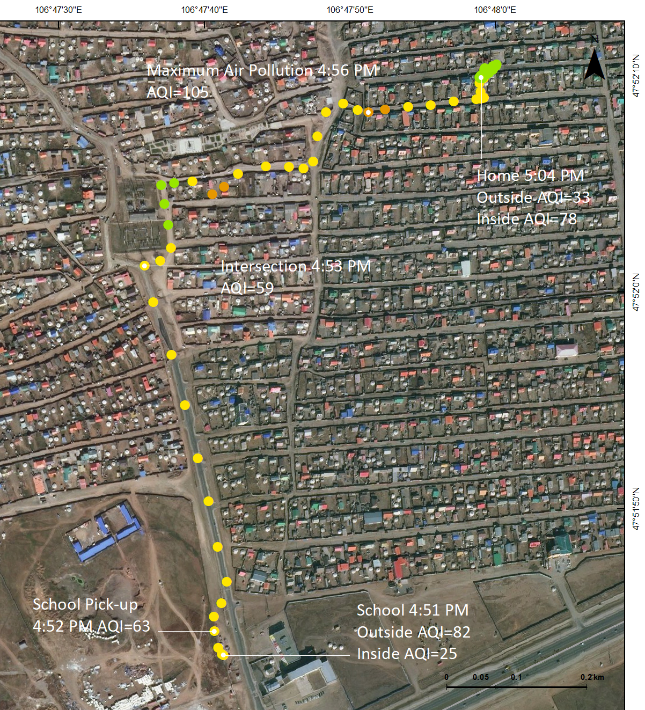

*Figure 17.* [pilot test individual #8] Turbold’s commute from school to home 4:51-5:04 PM on March 12th, 2019. His maximum AQI value was 110 (PM 2.5 = 39 μg/m³) and minimum value was 29 (PM 2.5 = 7 μg/m³).

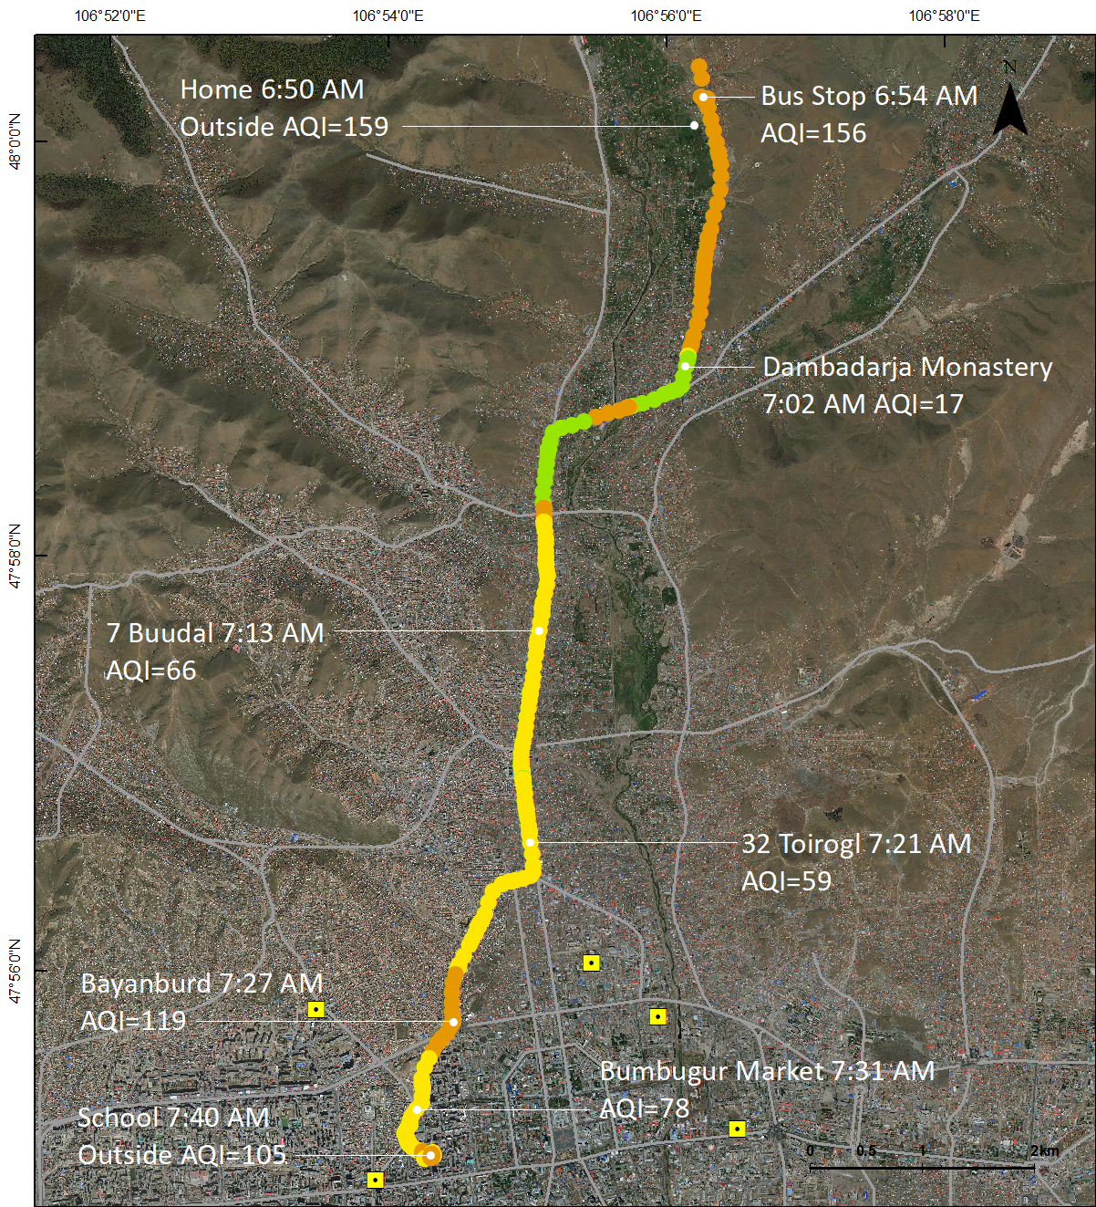

*Figure 18.* [pilot test individual #1] OyunErdene’s commute from home to school 6:50-7:40 AM on April 4th, 2019. Her maximum AQI value was 172 (PM 2.5 = 95.3 μg/m³) and minimum value was 8 (PM 2.5 = 2 μg/m³).

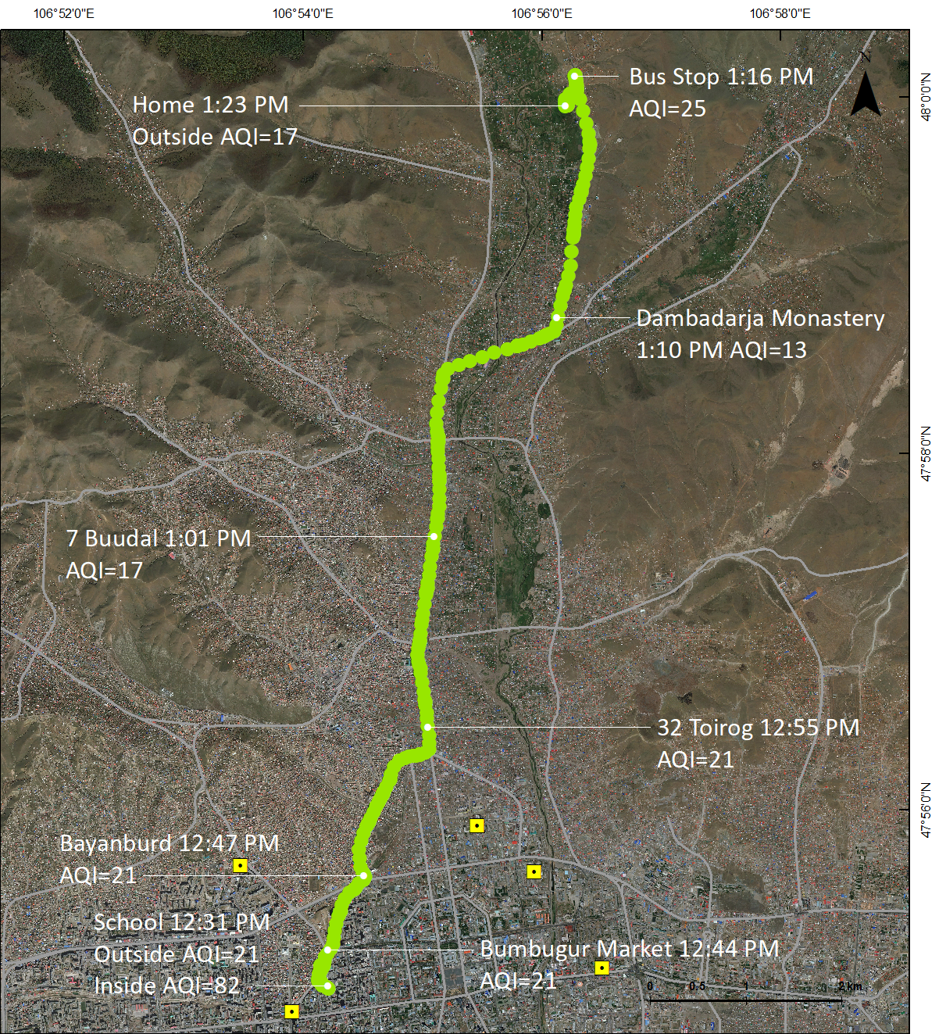

*Figure 19.* [pilot test individual #1] OyunErdene’s commute from school to home 12:31-1:23 PM on April 4th, 2019. Her maximum AQI value was 29 (PM 2.5 = 7 μg/m³) and minimum value was 13 (PM 2.5 = 3 μg/m³).